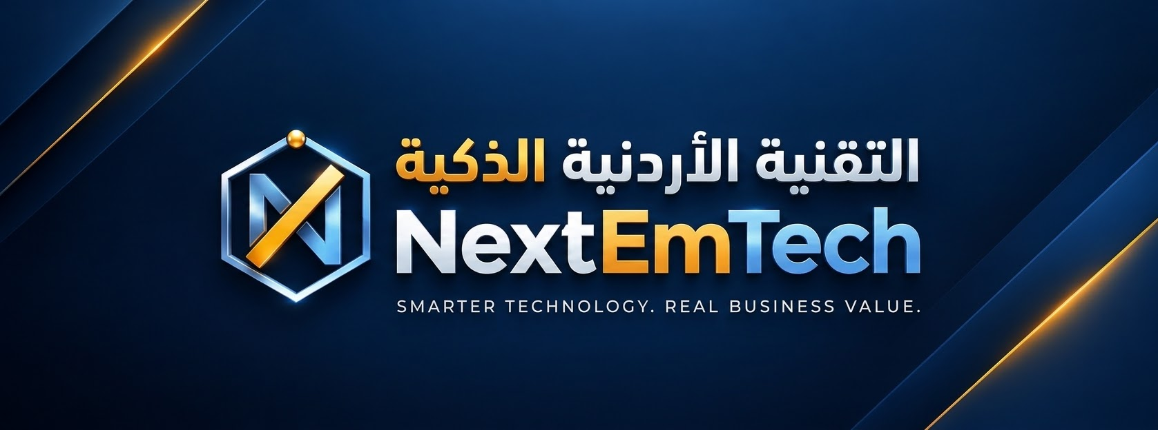
PMI RESOURCES AND MY LEARNING PATHWAY
EPM-JO Bootcamp · PMI Jordan Chapter × INJAZ mySTARTUP · Session 7 output · Not exam preparation
1. PMI RESOURCES
Resource | What it is | Access
PMI KICKOFF™ | Online course on project basics (agile or waterfall), templates, badge · ~45 min | pmi.org/kickoff
PMI membership | PMI resources, standards and community | pmi.org
PMI Infinity™ | PMI's AI assistant over PMI content, with sources | PMI members
PMI Jordan Chapter | Amman: development days, seminars, workshops, networking, volunteering | Chapter membership
PMI Project Management Ready™ | Entry certification for school and university students | Via Certiport
CAPM® | Entry-level certification (see the facts below) | Exam via PMI · pmi.org
PMI-CPMAI™ | Project management for AI products, data-first | Course and certification
PMP® | For experienced project leaders (e.g. 36 months leading projects + 4-year degree + 35 h) | Later in your career

2. CAPM FACTS
• Eligibility: secondary degree + 23 hours of project management education before the exam · no experience required
• Exam content (2023): fundamentals 36% · predictive 17% · agile 20% · business analysis 27% · 150 questions (reported)
• Today's workshop is not exam preparation and is not presented as counting toward the 23 hours. Check everything on pmi.org.

3. MY PATHWAY
Role: ☐ Founder ☐ Team member ☐ Student ☐ Technical / AI
Is CAPM for me now? ☐ Yes ☐ Not yet — because: ____________________________________________
My next 3 steps (90 days)
# | What I will do | By (date) | Evidence
1
2
3

I will tell (accountability partner): ____________________________ Name: ____________________________

Apply first, then certify when it helps your role · Handbook: nxemtech-startup.nextmtech.com

